Stop firewall before on all nodes before installer.

[root@gtmvlsbxdb13 ~]# systemctl status firewalld

[root@gtmvlsbxdb13 ~]# systemctl stop firewalld

[root@gtmvlsbxdb13 ~]# systemctl disable firewalld

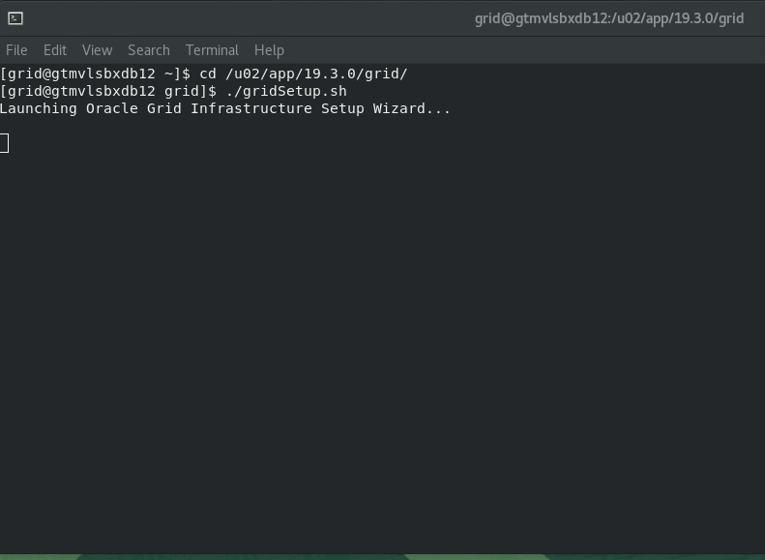

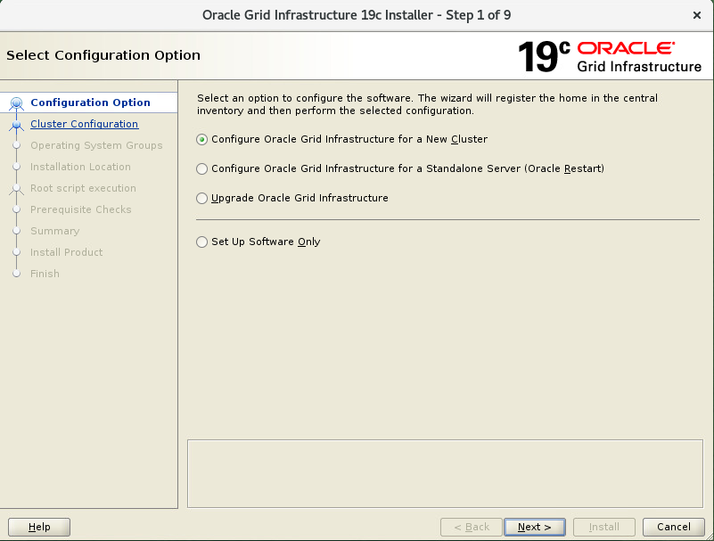

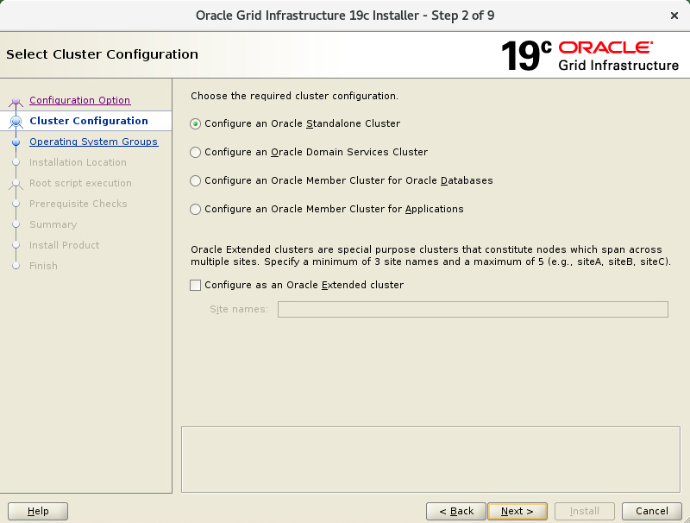

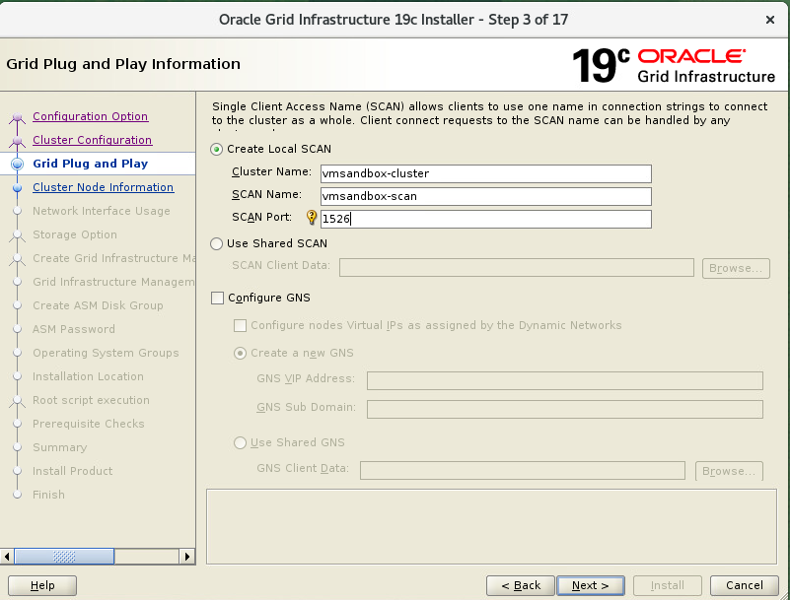

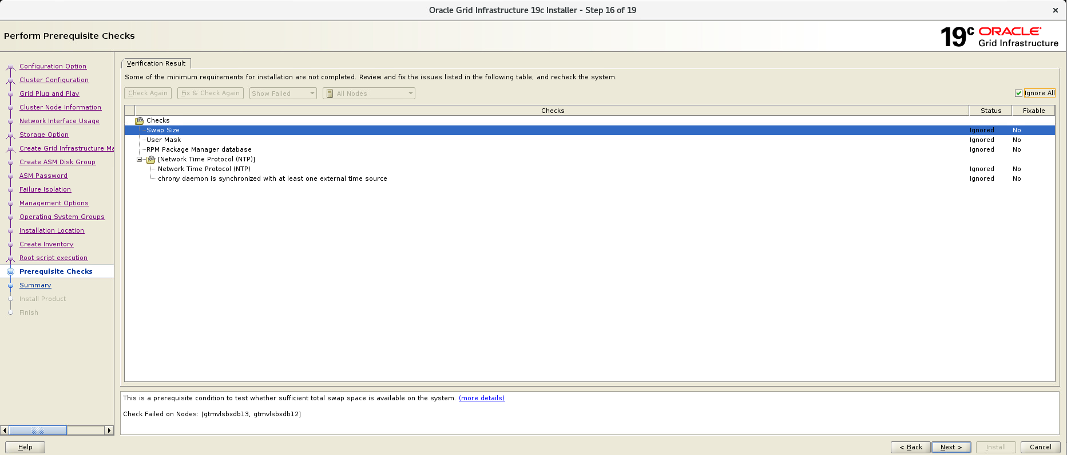

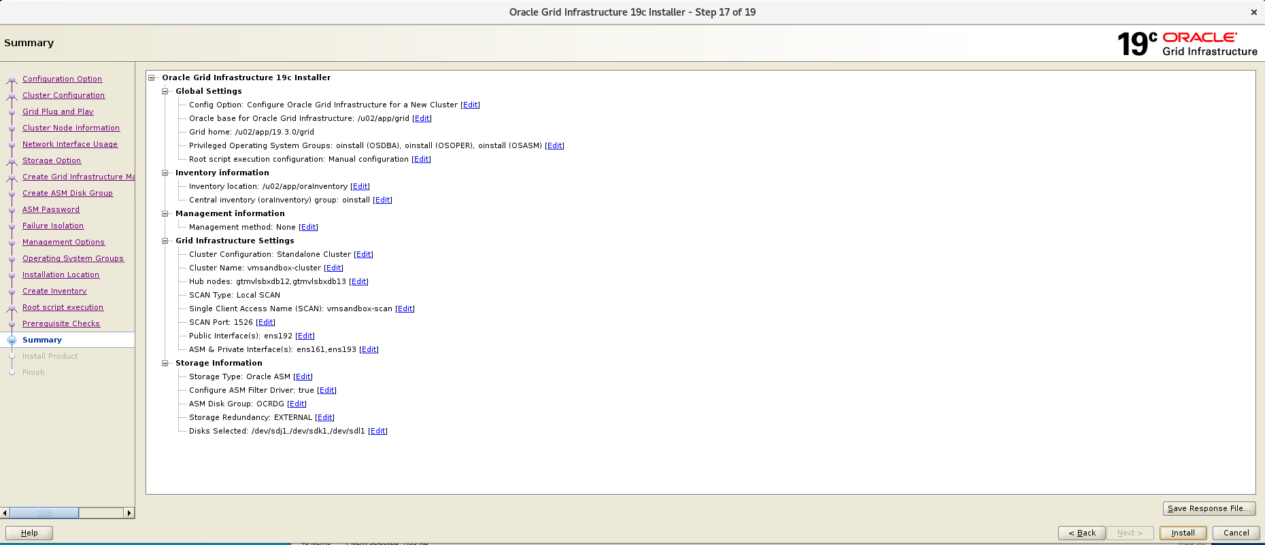

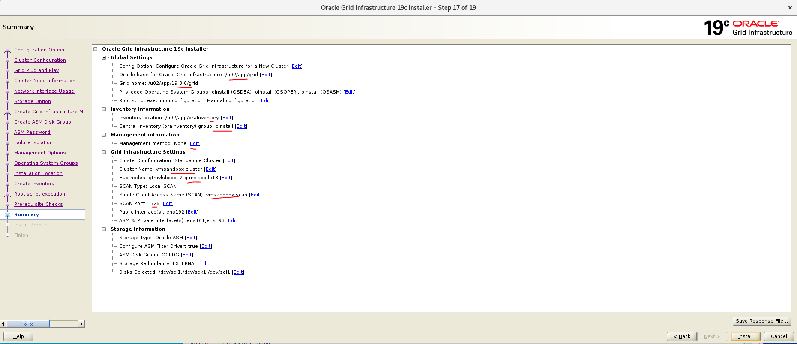

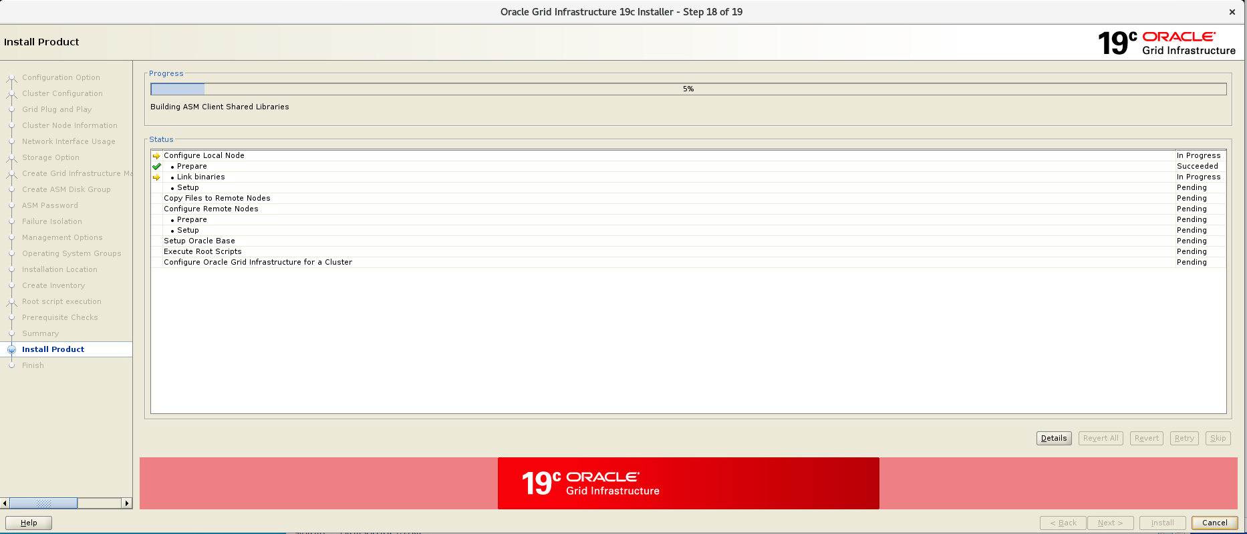

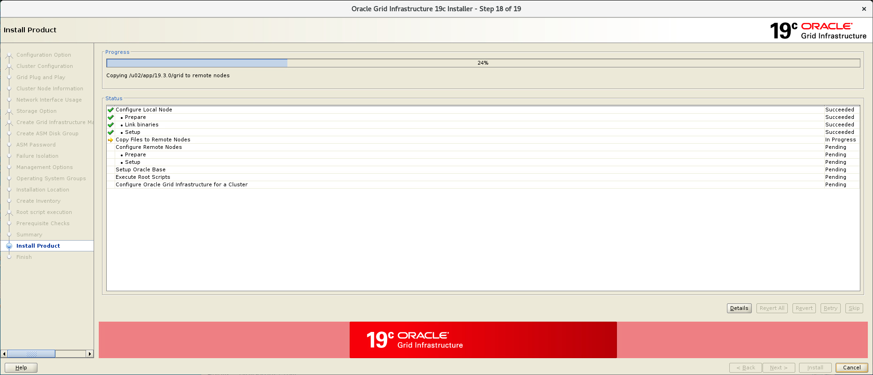

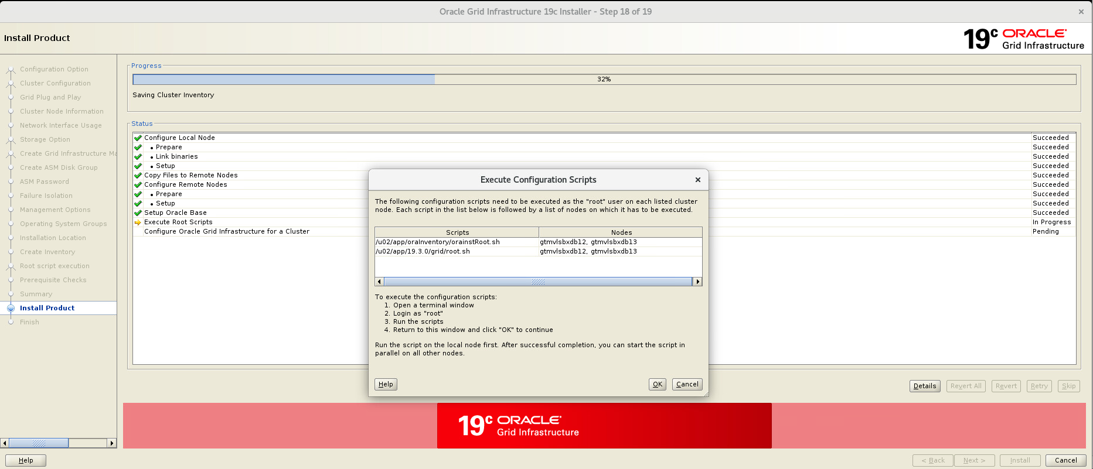

Node1:-

[root@gtmvlsbxdb12 oraInventory]# pwd

/u02/app/oraInventory

[root@gtmvlsbxdb12 oraInventory]# ./orainstRoot.sh

Changing permissions of /u02/app/oraInventory.

Adding read,write permissions for group.

Removing read,write,execute permissions for world.

Changing groupname of /u02/app/oraInventory to oinstall.

The execution of the script is complete.

[root@gtmvlsbxdb12 oraInventory]# pwd

/u02/app/oraInventory

[root@gtmvlsbxdb12 oraInventory]# cd /u02/app/19.3.0/grid/

[root@gtmvlsbxdb12 grid]# ./root.sh

Performing root user operation.

The following environment variables are set as:

ORACLE_OWNER= grid

ORACLE_HOME= /u02/app/19.3.0/grid

Enter the full pathname of the local bin directory: [/usr/local/bin]:

Copying dbhome to /usr/local/bin ...

Copying oraenv to /usr/local/bin ...

Copying coraenv to /usr/local/bin ...

Creating /etc/oratab file...

Entries will be added to the /etc/oratab file as needed by

Database Configuration Assistant when a database is created

Finished running generic part of root script.

Now product-specific root actions will be performed.

Relinking oracle with rac_on option

Using configuration parameter file: /u02/app/19.3.0/grid/crs/install/crsconfig_params

The log of current session can be found at:

/u02/app/grid/crsdata/gtmvlsbxdb12/crsconfig/rootcrs_gtmvlsbxdb12_2023-08-25_11-23-38AM.log

2023/08/25 11:23:58 CLSRSC-594: Executing installation step 1 of 19: 'ValidateEnv'.

2023/08/25 11:23:58 CLSRSC-594: Executing installation step 2 of 19: 'CheckFirstNode'.

2023/08/25 11:24:01 CLSRSC-594: Executing installation step 3 of 19: 'GenSiteGUIDs'.

2023/08/25 11:24:03 CLSRSC-594: Executing installation step 4 of 19: 'SetupOSD'.

Redirecting to /bin/systemctl restart rsyslog.service

2023/08/25 11:24:04 CLSRSC-594: Executing installation step 5 of 19: 'CheckCRSConfig'.

2023/08/25 11:24:04 CLSRSC-594: Executing installation step 6 of 19: 'SetupLocalGPNP'.

2023/08/25 11:24:18 CLSRSC-594: Executing installation step 7 of 19: 'CreateRootCert'.

2023/08/25 11:24:23 CLSRSC-594: Executing installation step 8 of 19: 'ConfigOLR'.

2023/08/25 11:24:45 CLSRSC-594: Executing installation step 9 of 19: 'ConfigCHMOS'.

2023/08/25 11:24:46 CLSRSC-594: Executing installation step 10 of 19: 'CreateOHASD'.

2023/08/25 11:24:53 CLSRSC-594: Executing installation step 11 of 19: 'ConfigOHASD'.

2023/08/25 11:25:01 CLSRSC-330: Adding Clusterware entries to file 'oracle-ohasd.service'

2023/08/25 11:25:35 CLSRSC-594: Executing installation step 12 of 19: 'SetupTFA'.

2023/08/25 11:25:35 CLSRSC-594: Executing installation step 13 of 19: 'InstallAFD'.

2023/08/25 11:26:23 CLSRSC-594: Executing installation step 14 of 19: 'InstallACFS'.

2023/08/25 11:27:14 CLSRSC-594: Executing installation step 15 of 19: 'InstallKA'.

2023/08/25 11:27:22 CLSRSC-594: Executing installation step 16 of 19: 'InitConfig'.

[INFO] [DBT-30161] Disk label(s) created successfully. Check /u02/app/grid/cfgtoollogs/asmca/asmca-230825AM112757.log for details.

2023/08/25 11:29:00 CLSRSC-482: Running command: '/u02/app/19.3.0/grid/bin/ocrconfig -upgrade grid oinstall'

CRS-4256: Updating the profile

Successful addition of voting disk 16ffdc29c4424fcbbfaf7dcdbfd50d79.

Successfully replaced voting disk group with +OCRDG.

CRS-4256: Updating the profile

CRS-4266: Voting file(s) successfully replaced

## STATE File Universal Id File Name Disk group

-- ----- ----------------- --------- ---------

1. ONLINE 16ffdc29c4424fcbbfaf7dcdbfd50d79 (AFD:VMSANDBOX_ASM_DISK_01) [OCRDG]

Located 1 voting disk(s).

2023/08/25 11:30:21 CLSRSC-4002: Successfully installed Oracle Trace File Analyzer (TFA) Collector.

2023/08/25 11:30:24 CLSRSC-594: Executing installation step 17 of 19: 'StartCluster'.

2023/08/25 11:31:44 CLSRSC-343: Successfully started Oracle Clusterware stack

2023/08/25 11:31:44 CLSRSC-594: Executing installation step 18 of 19: 'ConfigNode'.

2023/08/25 11:33:08 CLSRSC-594: Executing installation step 19 of 19: 'PostConfig'.

2023/08/25 11:33:46 CLSRSC-325: Configure Oracle Grid Infrastructure for a Cluster ... succeeded

[root@gtmvlsbxdb12 grid]# ps -eaf|grep -i pmon

grid 523390 1 0 11:31 ? 00:00:00 asm_pmon_+ASM1

root 534958 491223 0 11:34 pts/21 00:00:00 grep --color=auto -i pmon

[root@gtmvlsbxdb12 grid]#

Node2:-

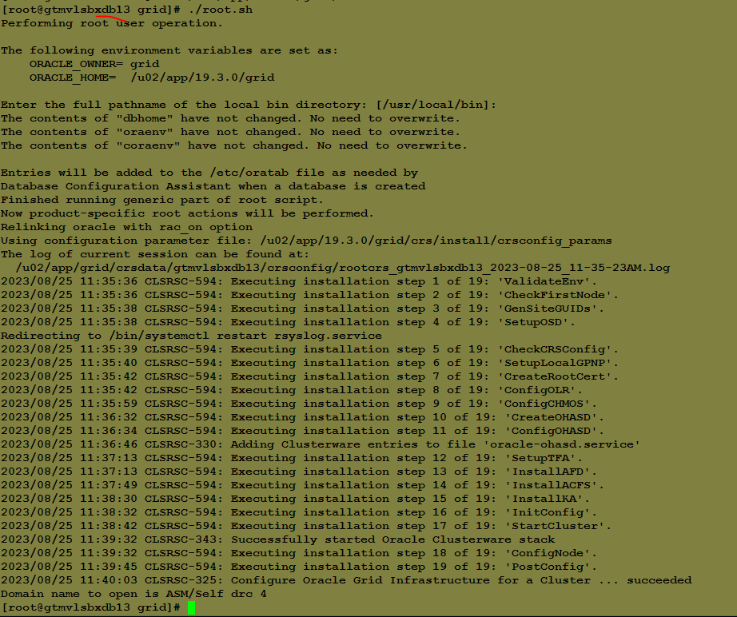

[root@gtmvlsbxdb13 oraInventory]# ./orainstRoot.sh

Changing permissions of /u02/app/oraInventory.

Adding read,write permissions for group.

Removing read,write,execute permissions for world.

Changing groupname of /u02/app/oraInventory to oinstall.

The execution of the script is complete.

[root@gtmvlsbxdb13 oraInventory]# timed out waiting for input: auto-logout

[oracle@gtmvlsbxdb13 ~]$ ps -eaf|grep -i pmon

oracle 157354 139552 0 11:34 pts/0 00:00:00 grep --color=auto -i pmon

[oracle@gtmvlsbxdb13 ~]$ sudo su -

Last login: Fri Aug 25 11:34:24 EDT 2023 on pts/1

[root@gtmvlsbxdb13 ~]# cd /u02/app/19.3.0/grid/

[root@gtmvlsbxdb13 grid]# ./root.sh

Performing root user operation.

The following environment variables are set as:

ORACLE_OWNER= grid

ORACLE_HOME= /u02/app/19.3.0/grid

Enter the full pathname of the local bin directory: [/usr/local/bin]:

The contents of "dbhome" have not changed. No need to overwrite.

The contents of "oraenv" have not changed. No need to overwrite.

The contents of "coraenv" have not changed. No need to overwrite.

Entries will be added to the /etc/oratab file as needed by

Database Configuration Assistant when a database is created

Finished running generic part of root script.

Now product-specific root actions will be performed.

Relinking oracle with rac_on option

Using configuration parameter file: /u02/app/19.3.0/grid/crs/install/crsconfig_params

The log of current session can be found at:

/u02/app/grid/crsdata/gtmvlsbxdb13/crsconfig/rootcrs_gtmvlsbxdb13_2023-08-25_11-35-23AM.log

2023/08/25 11:35:36 CLSRSC-594: Executing installation step 1 of 19: 'ValidateEnv'.

2023/08/25 11:35:36 CLSRSC-594: Executing installation step 2 of 19: 'CheckFirstNode'.

2023/08/25 11:35:38 CLSRSC-594: Executing installation step 3 of 19: 'GenSiteGUIDs'.

2023/08/25 11:35:38 CLSRSC-594: Executing installation step 4 of 19: 'SetupOSD'.

Redirecting to /bin/systemctl restart rsyslog.service

2023/08/25 11:35:39 CLSRSC-594: Executing installation step 5 of 19: 'CheckCRSConfig'.

2023/08/25 11:35:40 CLSRSC-594: Executing installation step 6 of 19: 'SetupLocalGPNP'.

2023/08/25 11:35:42 CLSRSC-594: Executing installation step 7 of 19: 'CreateRootCert'.

2023/08/25 11:35:42 CLSRSC-594: Executing installation step 8 of 19: 'ConfigOLR'.

2023/08/25 11:35:59 CLSRSC-594: Executing installation step 9 of 19: 'ConfigCHMOS'.

2023/08/25 11:36:32 CLSRSC-594: Executing installation step 10 of 19: 'CreateOHASD'.

2023/08/25 11:36:34 CLSRSC-594: Executing installation step 11 of 19: 'ConfigOHASD'.

2023/08/25 11:36:46 CLSRSC-330: Adding Clusterware entries to file 'oracle-ohasd.service'

2023/08/25 11:37:13 CLSRSC-594: Executing installation step 12 of 19: 'SetupTFA'.

2023/08/25 11:37:13 CLSRSC-594: Executing installation step 13 of 19: 'InstallAFD'.

2023/08/25 11:37:49 CLSRSC-594: Executing installation step 14 of 19: 'InstallACFS'.

2023/08/25 11:38:30 CLSRSC-594: Executing installation step 15 of 19: 'InstallKA'.

2023/08/25 11:38:32 CLSRSC-594: Executing installation step 16 of 19: 'InitConfig'.

2023/08/25 11:38:42 CLSRSC-594: Executing installation step 17 of 19: 'StartCluster'.

2023/08/25 11:39:32 CLSRSC-343: Successfully started Oracle Clusterware stack

2023/08/25 11:39:32 CLSRSC-594: Executing installation step 18 of 19: 'ConfigNode'.

2023/08/25 11:39:45 CLSRSC-594: Executing installation step 19 of 19: 'PostConfig'.

2023/08/25 11:40:03 CLSRSC-325: Configure Oracle Grid Infrastructure for a Cluster ... succeeded

Domain name to open is ASM/Self drc 4

[root@gtmvlsbxdb13 grid]# 2023/08/25 11:41:21 CLSRSC-4002: Successfully installed Oracle Trace File Analyzer (TFA) Collector.

